WOOLSTON COMMUNITY ASSOCIATION
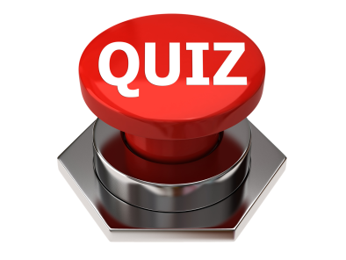
QUIZ NIGHT
Woolston Community Centre
Saturday 12th May 2018
7.30-11pm

Max. 6 people per team. Over 18s only
Haven’t got a team? We’ll help you put one together on the night!

Tickets available from Linda Tyrie (02380 391485)
£2.00 WCA Members
£2.50 Non Members

Tickets also available online for £3.00
See our website facebook page for more information.

Please bring your own drinks and glasses - nibbles will be provided.

This event is brought to you by Woolston Community Centre Management Committee,
to raise funds for the maintenance and improvement of your community centre.
Charity No. 302000

