WOOLSTON COMMUNITY ASSOCIATION
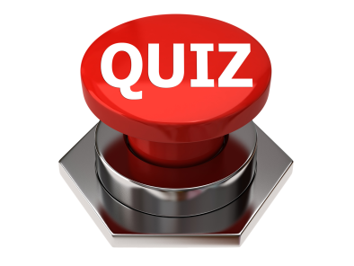
QUIZ NIGHT
Woolston Community Centre
Saturday 15th February 2020
7.30-11pm
Max. 6 people per team. Over 18s only
Haven’t got a team? We’ll help you put one together on the night!
Tickets available from
Lesley- tel:023 80431073. e-mail: lsteege@btinternet.com or,
Joan- tel:07847 148738. e-mail: joan.winstanley@btinternet.com.
£2.50 WCA Members
£3.00 Non Members
Please bring your own drinks and glasses - nibbles will be provided – don’t forget the bottle opener!
This event is brought to you by Woolston Community Centre Management Committee,
to raise funds for the maintenance and improvement of your community centre.
Charity No. 302000

